Coeus Solutions

10/21/2015

Business Flow Document

CovetMe Project

**Table of Content**

1.0 SignUp 4

1.0.1 Signing up by entering required field 4

1.0.2 Account Activation 5

1.0.3 Sign up by Facebook account 6

1.0.4 Sign up by Twitter account 6

1.0.5 What’s your style score 6

2.0 Login 8

2.0.1 Forgot Password 8

3.0 Home Screen 10

**3.0.1** **User Menu** 10

3.0.1(A) View Profile 10

3.0.2(B) Edit Profile 11

3.0.1(C) Help 12

3.0.1(D) Logout 12

**3.0.2** **See All Rewards** 13

**3.0.3** **How To Use CovetMe** 14

**3.0.4** **Invite A Friend** 14

3.0.4 (A) Reward Points for Inviting Friends 15

4.0 Create Covet 16

5.0 Types of Posts 20

**5.0.1** **Product Post** 20

**5.0.2** **Collection Post** 21

5.0.2(A) Upload a Selfie or Outfit Picture 21

**5.0.3** **Advertiser Post** 28

5.0.3(A) Pricing for Advertisers & User Quality Score 28

6.0 Login As Advertiser 29

6.0.1 Create New Campaign 29

6.0.2 Advertiser Dashboard 33

6.0.3 Add Funds 34

7.0 Tech Stuff 36

8.0 Tools/Languages 37

9.0 Few more Technical Stuff 37

10.0 CovetMe Image Recognition 38

11.0 Outlook 38

12.0 Advertiser Public Social Rank & Brand Monitoring 40

# 1.0 Sign Up

At ‘Signup’ screen user can be able to Sign up by:

* Entering required fields
* Facebook account
* Gmail account

# 1.0.1 Signing up by entering required field

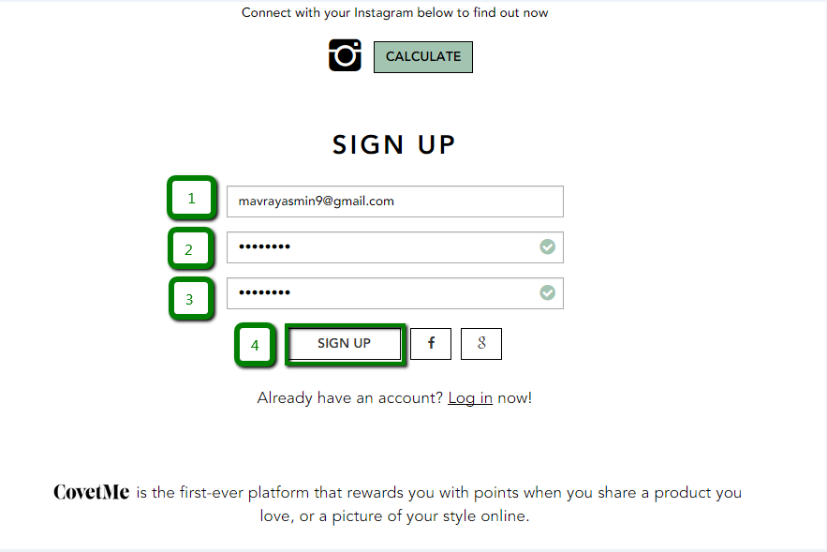

Figure 1.0.1 Signup form

1. Enter valid email address in email field
2. Enter valid password in password field
3. Retype the same password in next field
4. Click on ‘Sign up’ button at end of fields

Right after ‘Sign up’ button is clicked user will be logged in to Covet Me and will be redirected to following screen:

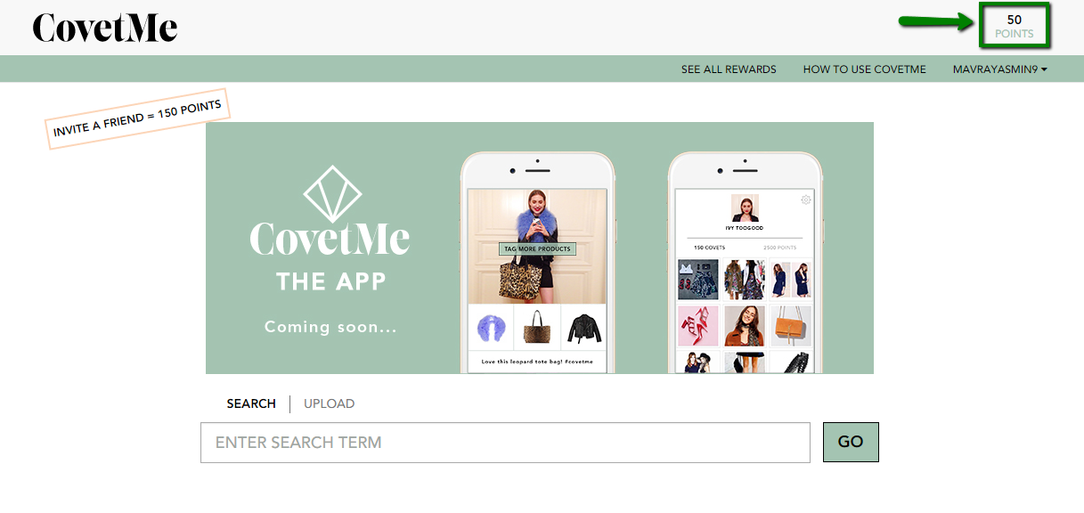

Figure 1.0.1 (a) Reward points on signup

User would be able to get 50 Points on signing up to Covet Me. As mentioned in Figure 2.0.1(a) the attained points can be viewed at top right of screen.

# 1.0.2 Account Activation

Right after user signed up to CovetMe he’ll receive account activation email for activating his account as follows: <http://screencast.com/t/QBZsgHkehJ> . Success alert would appear right after user’s account gets activated.

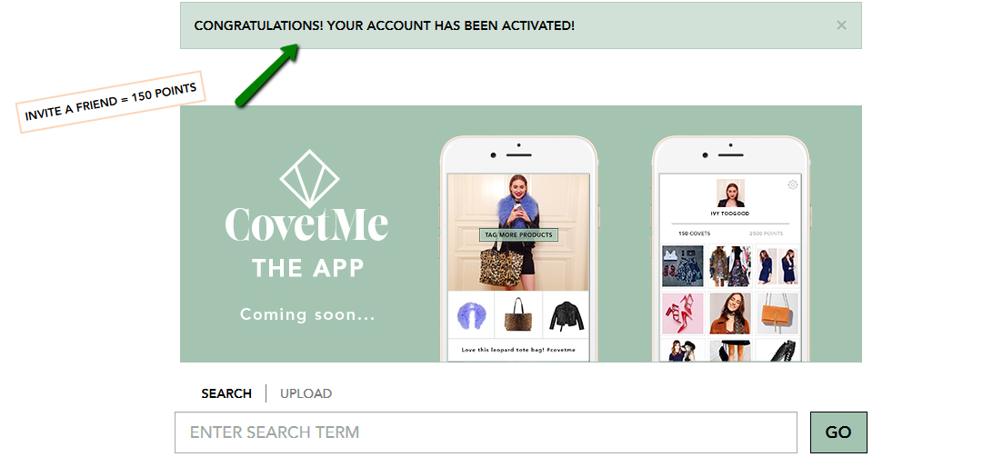

Figure 1.0.2 Success alert for activation

*\* Please note you cannot use same activation link twice*

# 1.0.3 Sign up by Facebook account

User can sign up from Facebook simply by providing his valid credentials for Facebook account.

# 1.0.4 Sign up by Gmail account

User can sign up from Gmail simply by providing his valid credentials for Gmail account.

# 1.0.5 What’s your style score

User can check his style score by clicking ‘Calculate’ button at Signup screen.

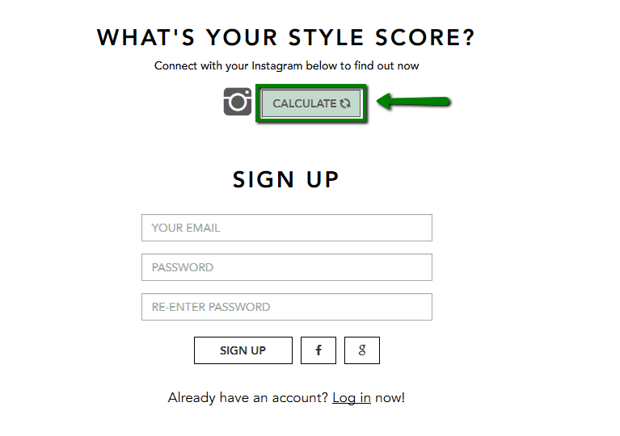

Figure 1.0.5 (a) Calculate style score

By clicking ‘Calculate’ button at Signup screen user would be redirected to following screen:

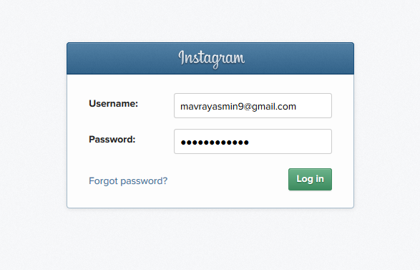

Figure 1.0.5 (b) Instagram login

User has to provide his Instagram credentials for calculating style scores. Before logging into Instagram CovetMe will ask for authorization. By allowing CovetMe to access your Instagram it will calculate your style scores and will display your scores at signup screen.

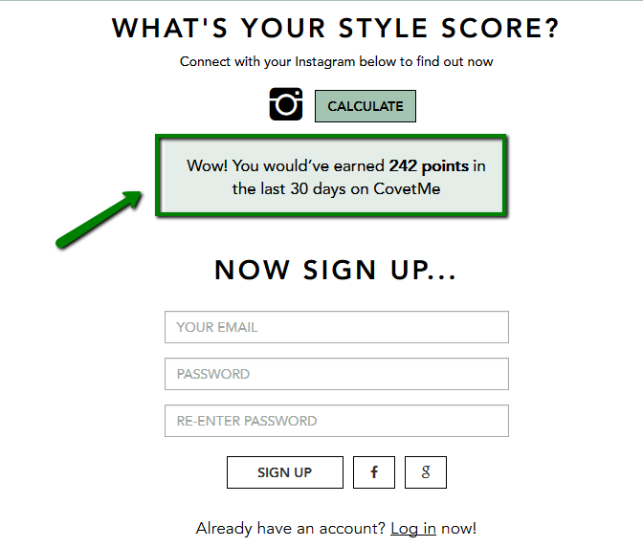

Figure 1.0.5 (c) Scores

# Log In

User can log in to CovetMe by clicking Login link below Signup form. Enter valid email address and password to log in to CovetMe.

User can also login from his Facebook/or Gmail account.

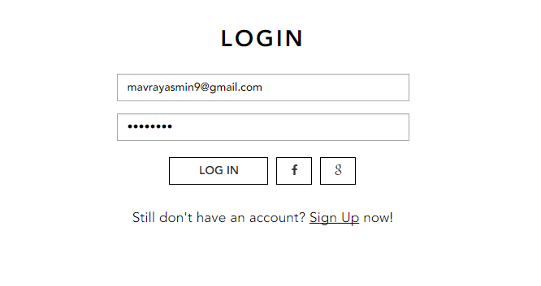

Figure 2.0 Login

# 2.0.1 Forgot Password

User can request a new password simply by clicking ‘Forgot your password’ link as shown below.

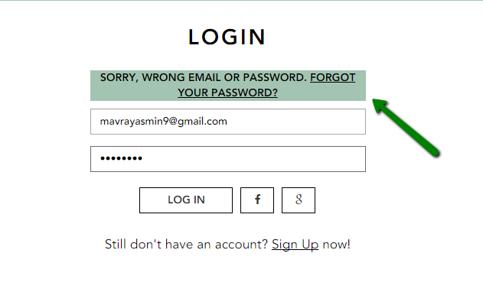

Figure 2.0.1 Forgot Password link

User has to enter his email address in very next step to get new password.

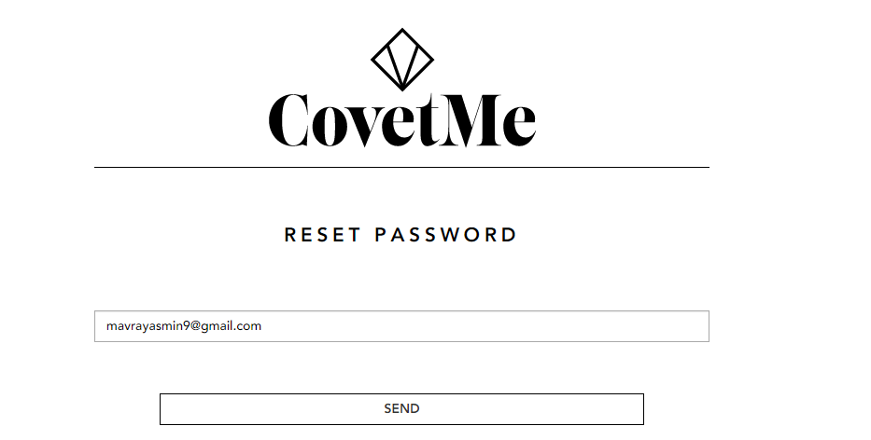

Figure 2.0.1 (a) Forgot Password Email Field

Right after ‘Send’ button is clicked a reset password link will be sent to user’s email address.

By clicking that link user will be redirected to reset password screen.

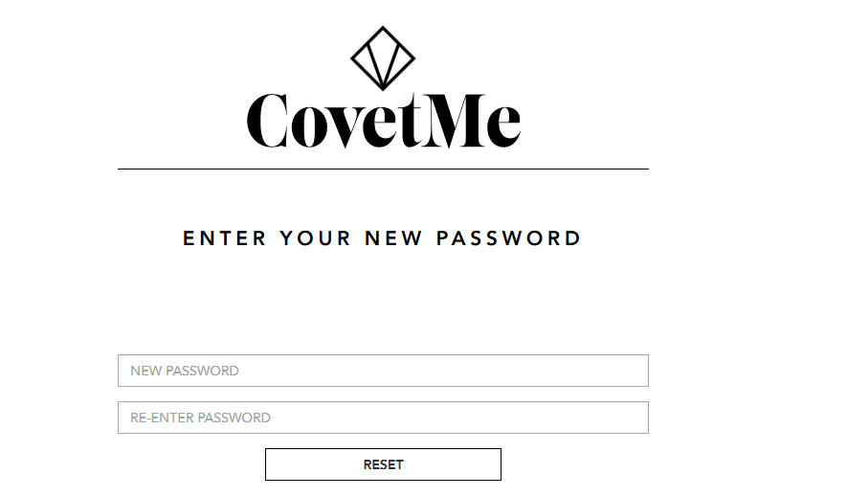

Figure 2.0.1 (b) Reset Password

Enter new password and retype password in next field. By clicking on ‘Reset’ link password will get reset and user will be logged into CovetMe site successfully.

# Home Screen

At CovetMe home screen navigation menu options will be displayed at header which are:

1. User menu
2. See all rewards
3. How to use CovetMe

# User Menu

User menu at extreme right of header includes following options:

1. View Profile
2. Edit Profile
3. Help
4. Logout

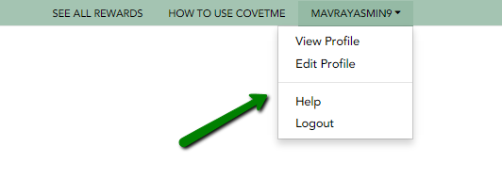

Figure 3.0.1 User Menu

# 3.0.1(A) View Profile

User can view his profile any time by selecting ‘View profile’ option from user’s menu at top right of header.

By selecting ‘View Profile’ option user will be redirected to following screen:

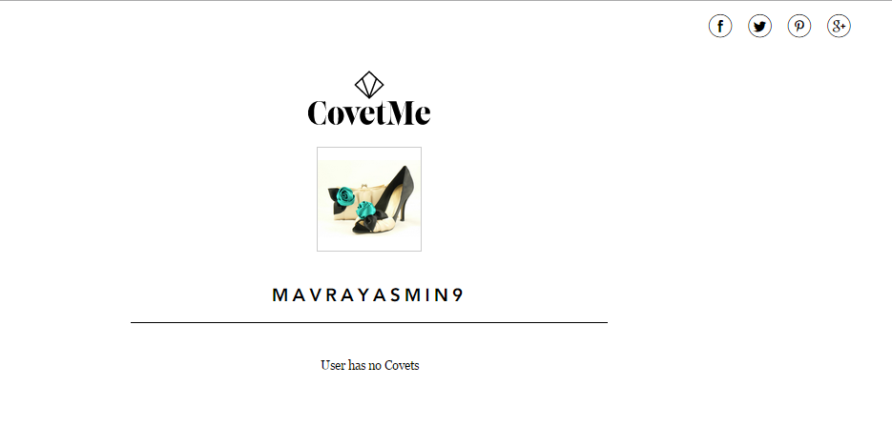

Figure 3.0.1(A) View Profile

# 3.0.1(B) Edit Profile

At edit profile page there are three sections:

* A section to edit profile picture and website
* A section to change password
* And a section to connect to social accounts – If user Is logged in from Facebook/or Gmail account that social account option will already be displayed as selected :

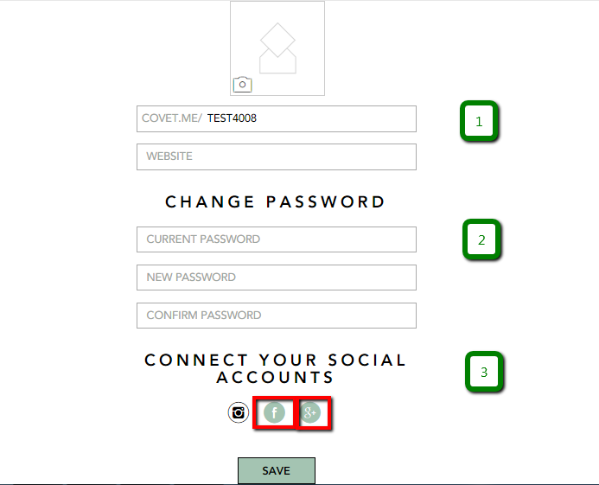

Figure 3.0.1(B) Edit Profile

User can upload his profile picture by clicking on picture. He can update his user name and enter his website link in first section.

User can change his password anytime in second section.

User can connect to his social accounts i.e. instagram, Facebook and Google plus in third section.

# 3.0.1(C) Help

By selecting ‘Help’ option from user’s menu user will be redirected to ‘How to use CovetMe’ page. *(Will be explained in next sections later)*

# 3.0.1(D) Logout

User can log out from his CovetMe account anytime by selecting ‘Logout’ option from user menu.

# See All Rewards

By clicking ‘See all Rewards’ from header user will be redirected to a page where user’s total reward points will be displayed with the vouchers (or gifts).

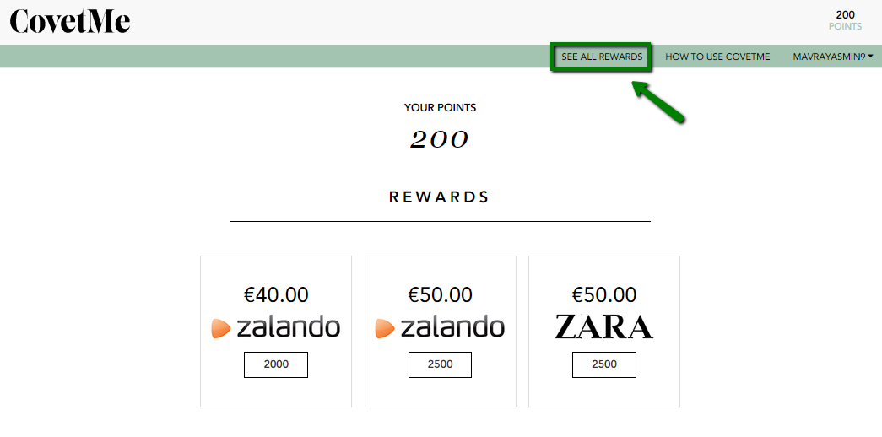

Figure 3.0.2 See All Rewards

By clicking the points button on voucher, system will be displayed below alert if in case you lack points to redeem the voucher.

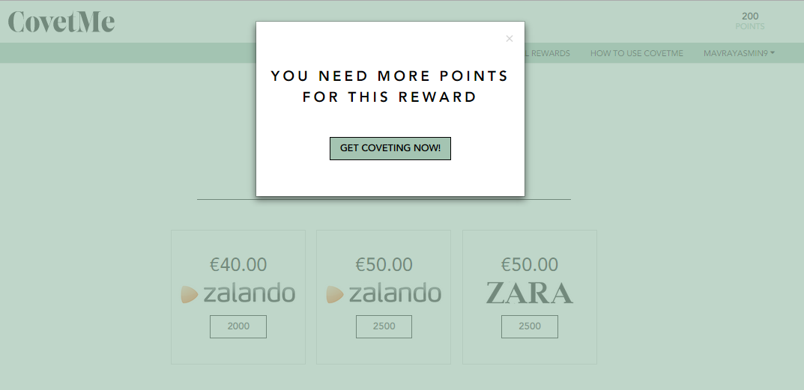

Figure 3.0.2 (b) Need more points popup

# How to Use CovetMe

This section will give all information regarding process behind using CovetMe. It is divided in following steps (<http://screencast.com/t/jjUaUBymi>):

1. How to create CovetMe link
2. Comment and hashtags
3. Share
4. Track your popularity
5. Collecting vouchers

User can take guidance regarding CovetMe simply by visiting ‘How to Use CovetMe’ page.

# Invite a Friend

CovetMe has provided this feature to invite your friends to join CovetMe too. For this, user has to click Invite a Friend link at top left of home page as mentioned in below figure:

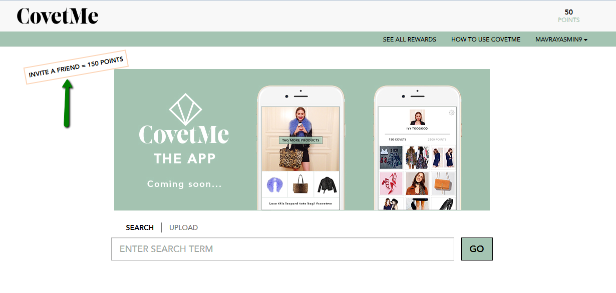

Figure 3.0.4 Invite a Friend button

By clicking ‘Invite a Friend’ link user will be redirected to a screen with email field where user has to enter email address of his friend.

By entering email address and by clicking ‘Send invitation Email’ button an email will be sent to mentioned email address.

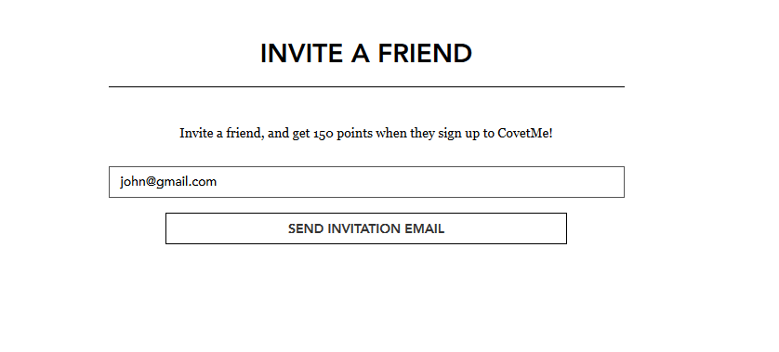Figure 3.0.4 (b) Invite a Friend

It is clearly stated in above screen shot that user will get 150 points on inviting his friend.

Invited user will receive following invitation email: <http://screencast.com/t/mFN5EHEHSp>

User can join CovetMe simply by clicking ‘Signup’ button provided in invitation email.

# 3.0.4(A) Reward Points for Inviting Friends

On activation of account, ***inviter*** will receive 150 points and total points will be displayed at top right of inviter’s CovetMe page.

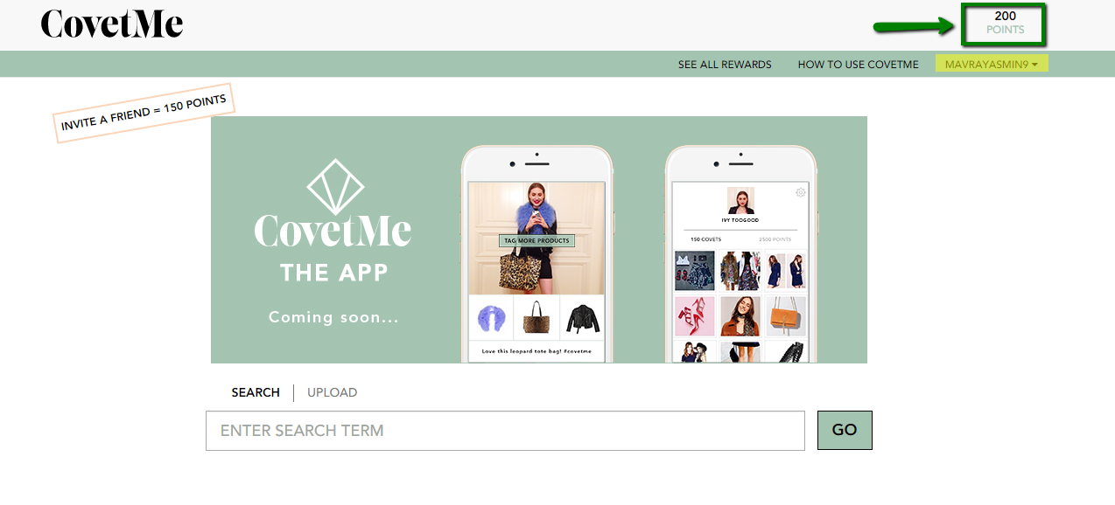

Figure 3.0.4 (A) b. Inviter’s Points

# Create Covet

User can create covets from products by selecting any product from home screen.

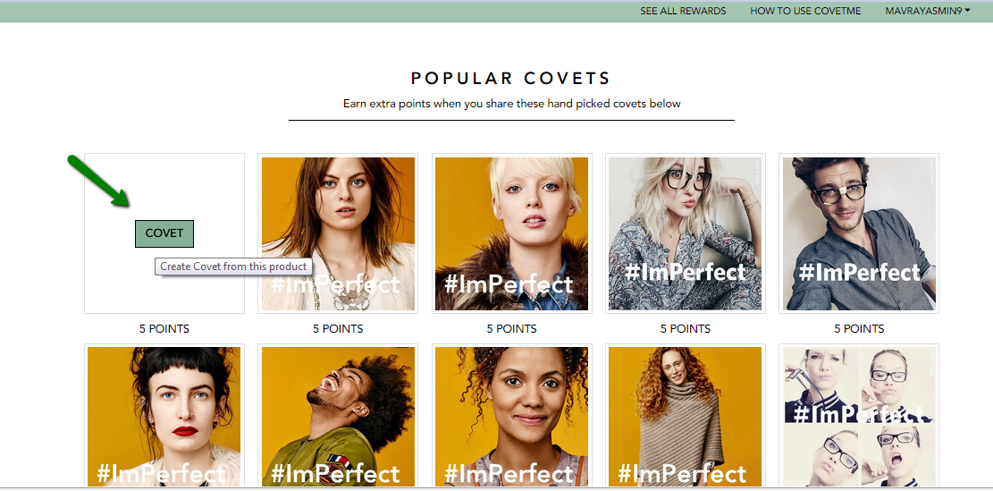

Figure 4.0 (a) Popular Covets

By clicking ‘Covet’ button on one of popular covets user will be redirected to following screen

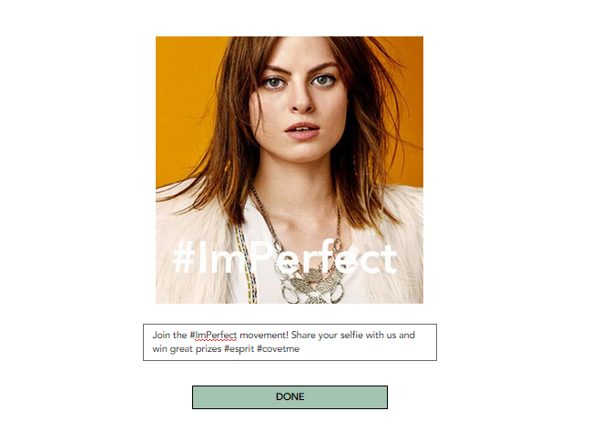

Figure 4.0 (b) Done Button

By clicking ‘Done’ button in above mentioned figure Covet url will be created and will be displayed after processing.

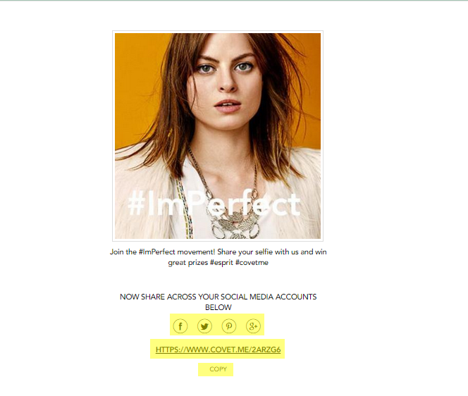

Figure 4.0 (c) Covet Url

User can share created covets on his social media accounts too, such as: Facebook, Twitter, Pinterest and Google plus by clicking respective social media icon.

Each time user shared covet on social media accounts he’ll gain points for sharing. The points will be displayed for each covet below respective picture (as displayed in Figure 4.0 (a)

By clicking ‘copy’, the covet url will get copied and can be sent to friend’s email ids or can be share on whatsapp.

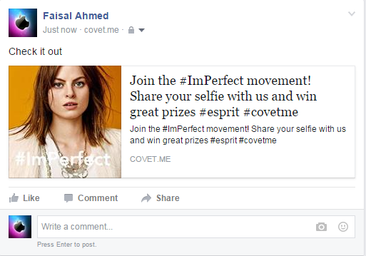

Figure 4.0 (d) Covet shared on Facebook

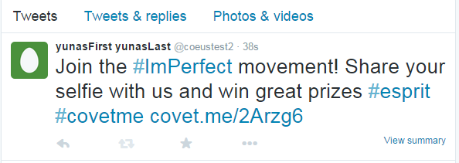

Figure 4.0 (e) Covet shared on Twitter

The increased points after sharing covets can be viewed in below mentioned figure.

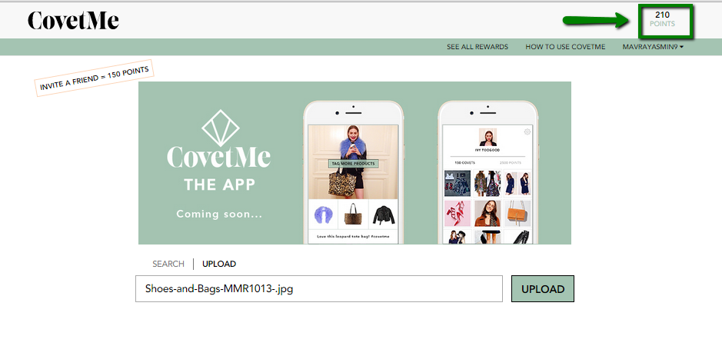

Figure 4.0 (f) Increased Points

Note you can only re-share the same covet after 30 min.

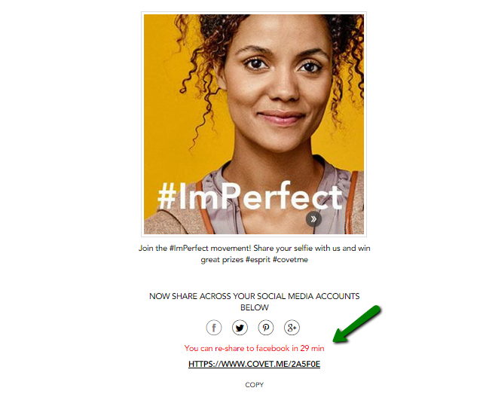

Figure 4.0 (g) Increased Points

# Types of Posts

There are three types of posts in Covet Me, these are:

1. Product Post
2. Collection Post
3. Advertiser Post

**5.0.1 Product Post**

Users can search a product from product database and simply share it. For Product Posts user will receive *dynamic* points per post depending on *likes and clicks*.

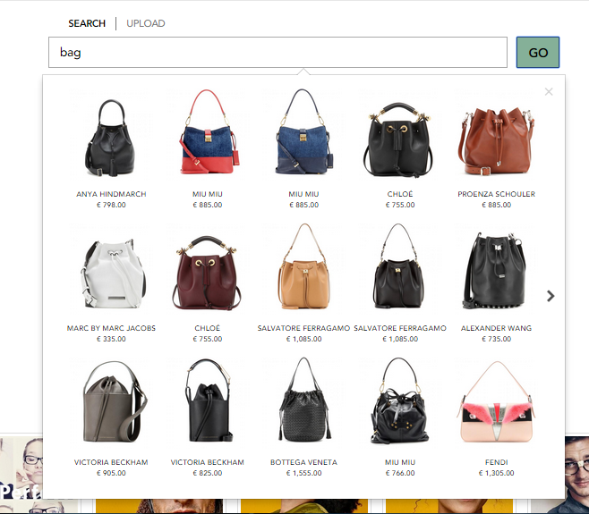

Figure 5.0.1 (a) Search Product

After selecting the specific product from search user will be redirected to following page with product picture, tag statement and ‘done’ button:

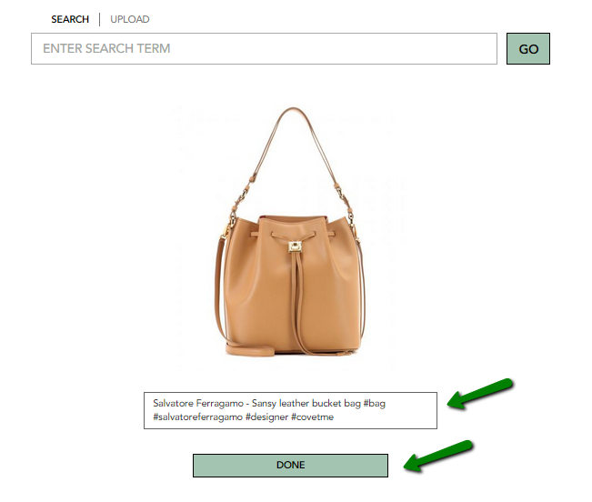

Figure 5.0.1 (b) Product detail page

By clicking ‘Done’ button a Covet will be created for that product and that can be shared on social media accounts.

For this Product Post user will get points *per share and click .*These products posts will directly link to the shop.

**5.0.2 Collection Post**

Same like Product post, for Collection post user will receive *dynamic* points per post depending on *likes and clicks.*

# 5.0.2(A) Upload a selfie or outfit picture:

User can upload his selfie or outfit picture simply by clicking ‘Upload’ link above ‘upload’ bar.

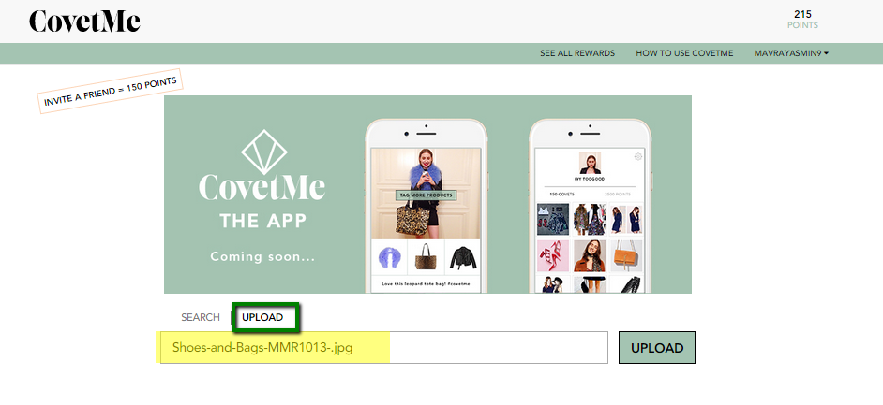

Figure 5.0.2 (A) Upload Selfie /or outfit picture

Right after user selects any image from his system the image name will appear in Upload bar.

Click upload button to upload the respective picture.

The next step after the image gets upload is to tag the image.

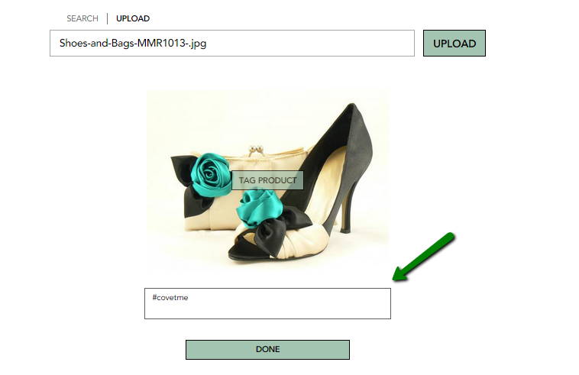

Figure 5.0.2 (A) [b] Tag your picture

You can also tag a product in uploaded picture by clicking ‘TAG PRODUCT’ label on the picture.

By clicking ‘TAG PRODUCT’ label a bar will appear to enter product url as seen in below figure.

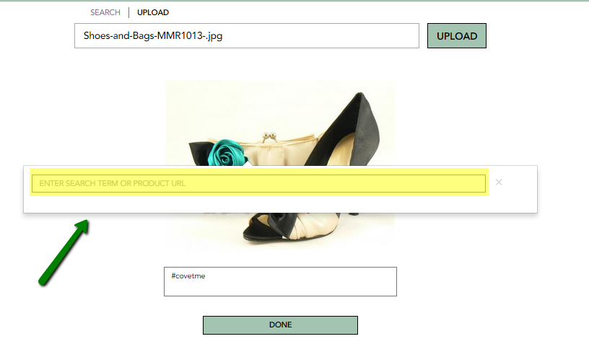

Figure 5.0.2 (A) [c] Tag Product

By entering product url in above bar all other products will be fetched from that url will be displayed right below the bar.

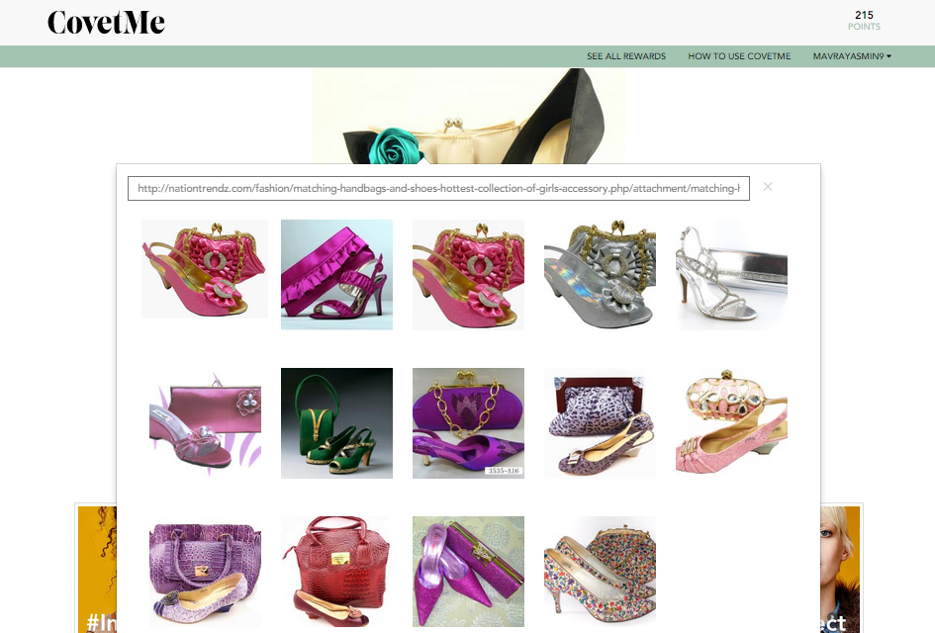

Figure 5.0.2 (A) [d] Imported products from url

Select any product from the displayed products’ images which you want to tag. The selected product will be tagged and will appear like this:

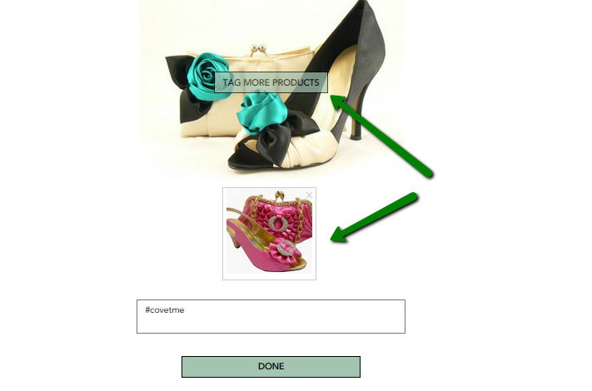

Figure 5.0.2 (A) [e] Tagged Product

User can tag even more products by clicking ‘TAG MORE PRODUCTS’ label above parent picture.

By clicking ‘Done’ button below the description box user’s covet will be created and displayed as:

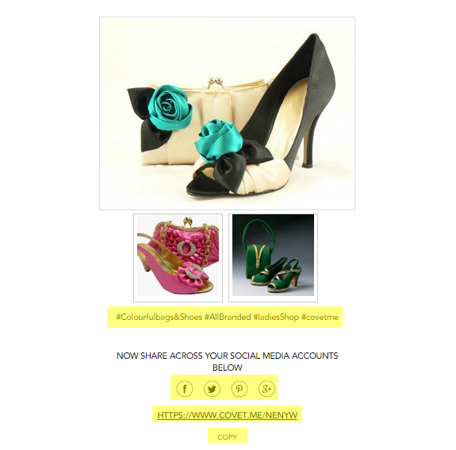

Figure 5.0.2 (A) [f] User’s Covet

On sharing your own covet you will get **1 point** for each share. Considering that user will receive 4 points if he share his own created covet on all 4 social accounts.

The covets created by user and the ones which he shared will be displayed under ‘Your Latest Covets’ section as mentioned in below figure:

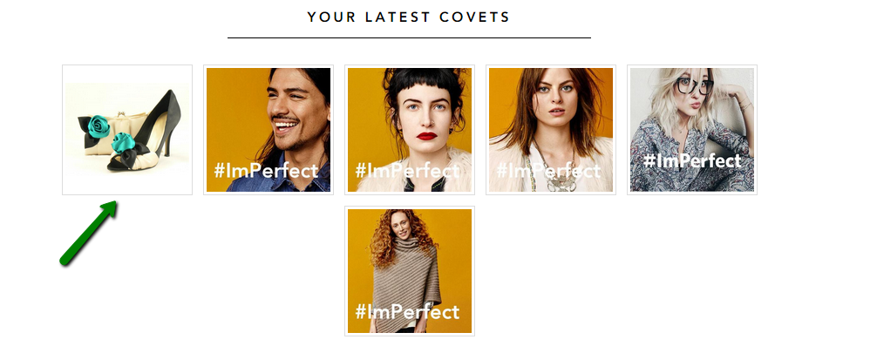

Figure 5.0.2 (A) [g] Your Latest Covets Section

On hover created/shared covet’s divs it will appear like:

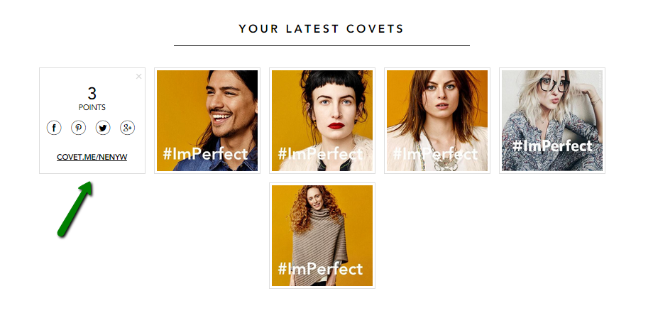

Figure 5.0.2 (A) [h] Your Covet Div

The gained points on sharing covets will be displayed right above the div with share options and a product link.

By clicking the link appearing on div, user will be redirected to following detail page (Bridge page) for respective product:

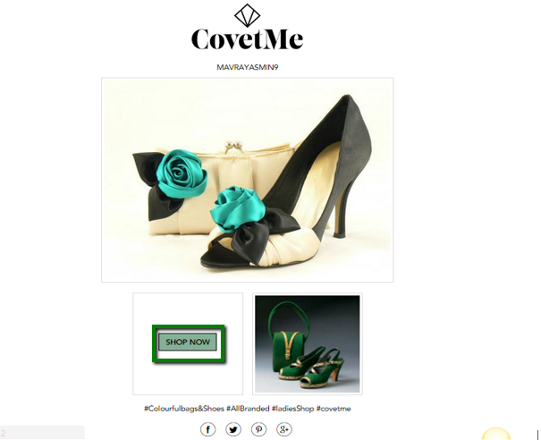

Figure 5.0.2 (A) [i] Bridge page

By clicking ‘Shop now’ on tagged product user will redirect to product home page. There is another section at product detail page which is ‘Other items you might like’. You can shop specific items by clicking the item and redirecting to the home page for that specific item.

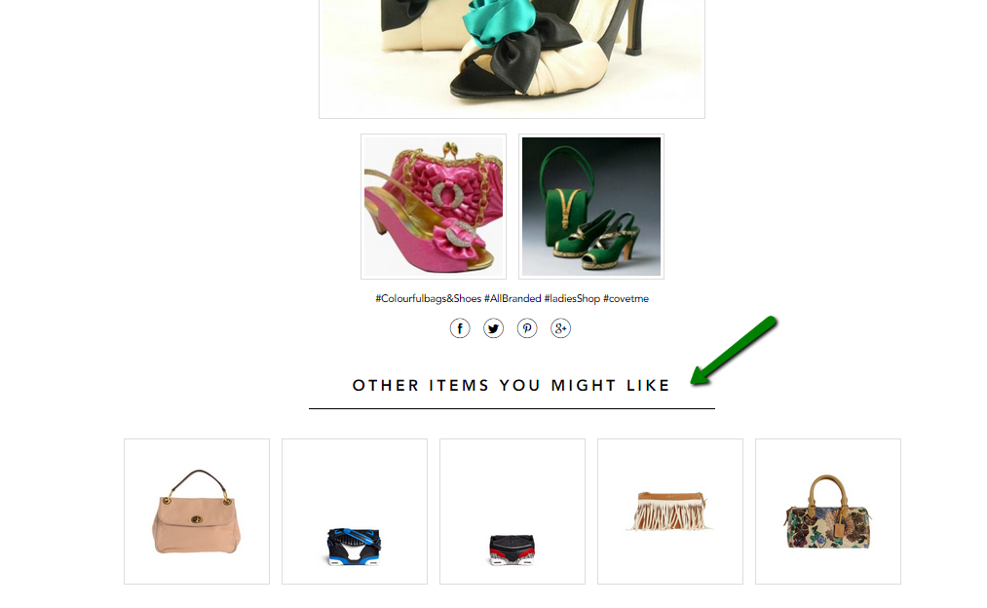

Figure 5.0.2 (A) [j] Other Items You Might Like

**5.0.3 Advertiser Post**

An advertiser post already has an image, text, hashtags and backlink defined by advertiser and is visible for user on his user dashboard in “Popular Covets” section. For Advertiser Post:

• User receives **fixed points** per post

• % of advertiser pay per post

• Points are independent from clicks or success of post

• But the points will depend on user quality score

*Advertiser will define a MAXIMUM PAY PER POST. For example he is willing to pay 1 EUR maximum. Users have quality score so each user will get VALUE PER POST based on his history and quality. Let’s say the user would get 14 points based on a calculation (Client will provide separately how it should be) he would receive these 14 points per post. This is on current currency 28 cents, so that user would actually be able to see and share the 1 EUR advertiser post. If a user quality is 250 points or something he wouldn’t see that post in his user backend*

**5.0.3(A) Pricing for Advertisers & User Quality Score**

* Advertiser can DEFINE A MAXIMUM PAY PER POST when launching a campaign
* He will never pay more than that price for a post
* He will pay less per post because most users don’t meet highest quality score
* Every CovetMe user has a quality score (mixture of CovetMe history, activity, likes etc.)
* This QS defines if he will get the full points of what advertiser is willing to pay or less
* So user basically gets ADVERTISERPAY * 30% * QS
* Advertiser pays ADVERTISERPAY * QS

# Login as Advertiser

Login with Advertiser’s credentials ([demo@citnb.com/demoaccount](mailto:demo@citnb.com/demoaccount)). Advertiser can create a new campaign. He can view list of all active, paused, draft campaigns, He can also edit the campaign and can change the status of campaign too.

**6.0.1 Create New Campaign**

Click on ‘Create New Campaign’ button at dashboard.

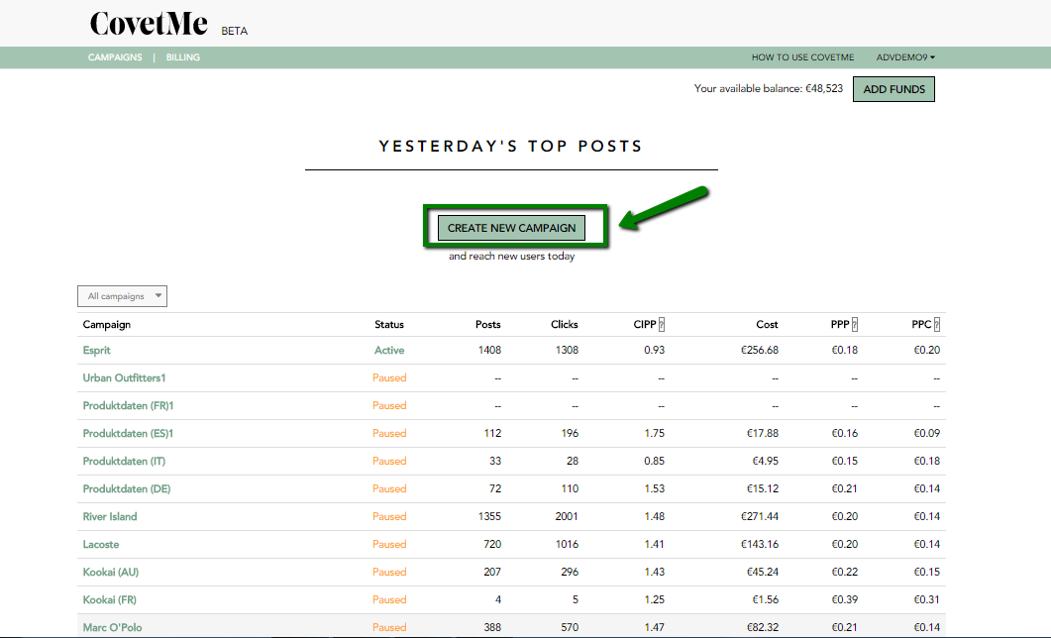

Figure 6.0.1 (a) Create New Campaign

Create campaign process is completed in 3 steps:

**Step 1:**

Enter campaign name and click on Next Step button to redirect to next step.

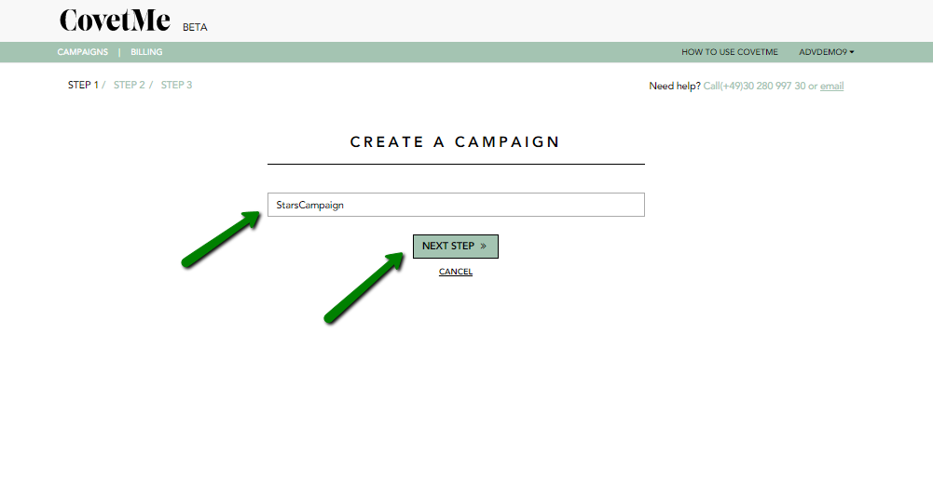

Figure 6.0.1 Create Campaign – Step 1

**Step 2:**

In step 2 upload image first for a campaign. Enter post caption and url for campaign. Click on ‘Next Step’ to move to 3rd step. The posts created by Advertiser will be displayed under ‘Popular Covets’ section for user’s view.

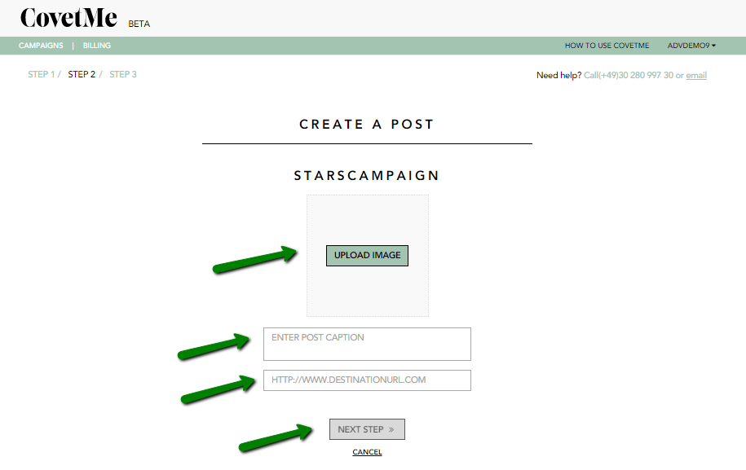

Figure 6.0.1 Create Campaign – Step 2

You can add multiple posts in Step 2 simply by clicking ‘Add More Posts’ link at bottom.

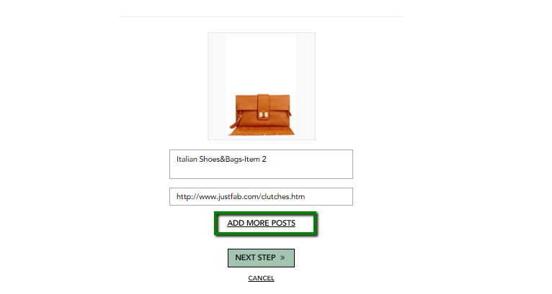

Figure 6.0.1 (b) Create Campaign – Add more Posts

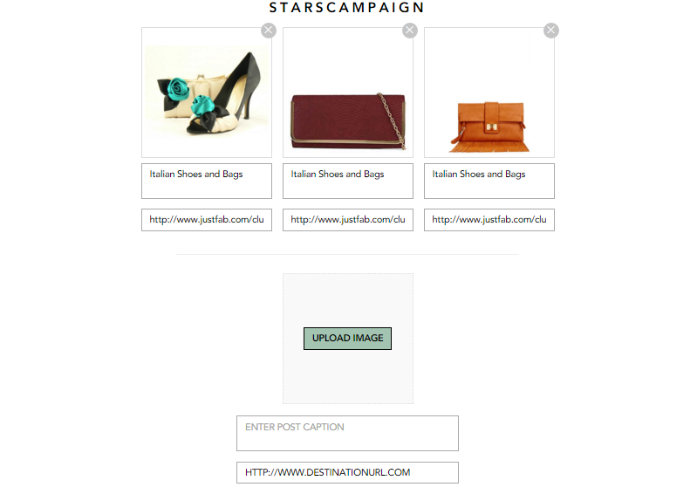

Figure 6.0.1 (c) Create Campaign – Adding Multiple Posts

**Step 3:**

In 3rd step user has to specify following:

1. Daily budget
2. Maximum budget
3. Maximum cost per share
4. Countries targeted
5. On which social sites advertiser want users to share that campaign

* Unable to create Campaign in some cases

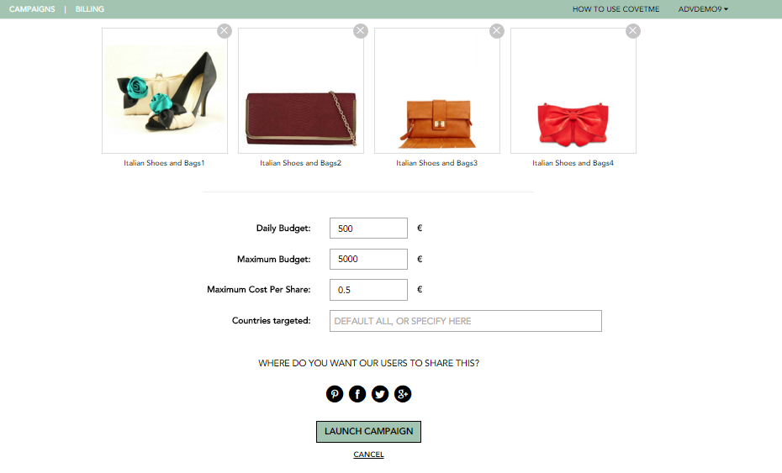

Figure 6.0 Create Campaign – Step 3

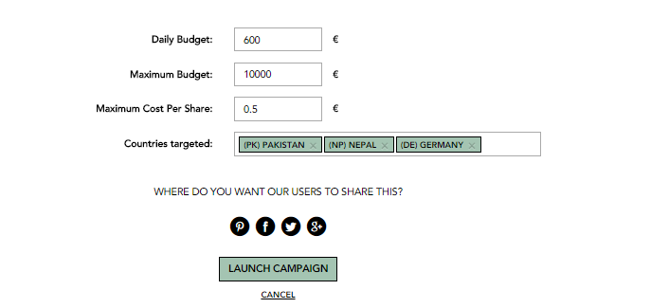

Figure 6.0.1 (b) Create Campaign – Step 3

**6.0.2 Advertiser’s Dashboard**

Advertiser would be able to view list of all campaigns at dashboard with all stats.

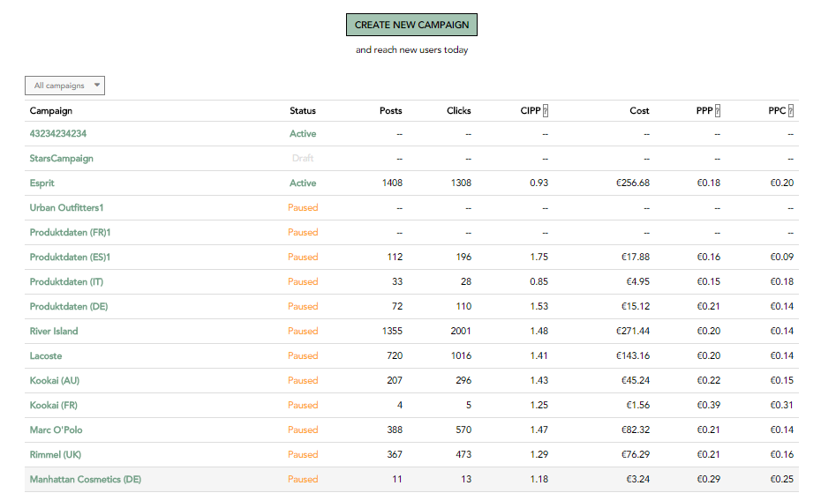

Figure 6.0.2 (a) Dashboard – Campaign listing

Advertiser can view the details of respective campaign by clicking Campaign title at dashboard. At detail screen of respective campaign:

* Advertiser would be able to view total shares (on social accounts) against each post.
* He’d be able to view all records related to respective post with dates.
* He’d be able to change the status of campaign
* He’d be able to edit the campaign

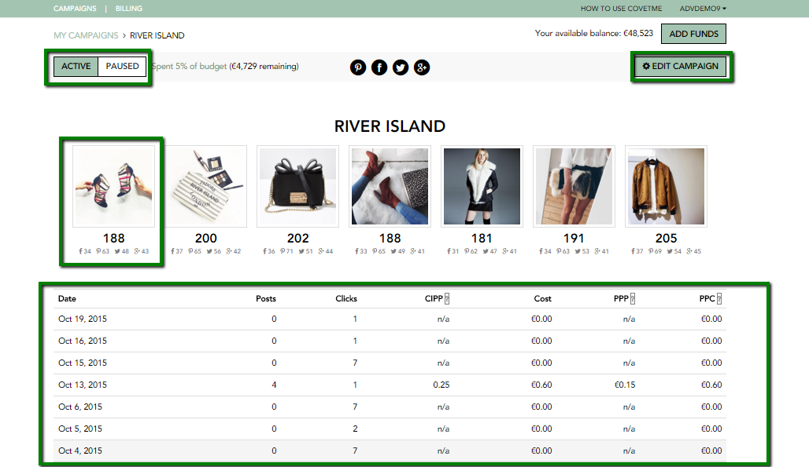

Figure 6.0.2 (b) Dashboard – Campaign detail screen

**6.0.3 Add Funds**

At top right of dashboard there is ‘Add Funds’ option. By clicking that option user will be redirected to following screen:

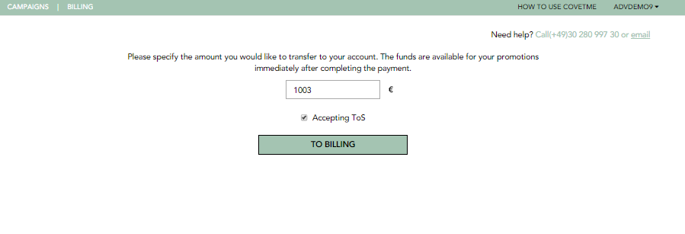

Figure 6.0.3 Dashboard – Add Funds

By entering billing amount and accepting terms of conditions user would be asked to enter billing address and contact details as shown below:

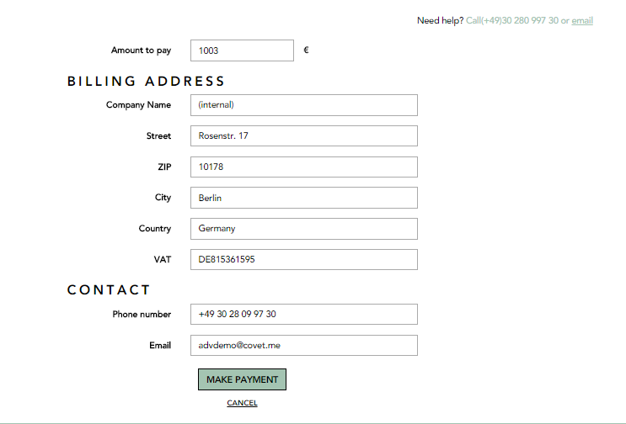

Figure 6.0.3 Dashboard – Billing Address & Contact form

By clicking make payment after entering all details a thank you message would be displayed at last screen.

# Tech Stuff

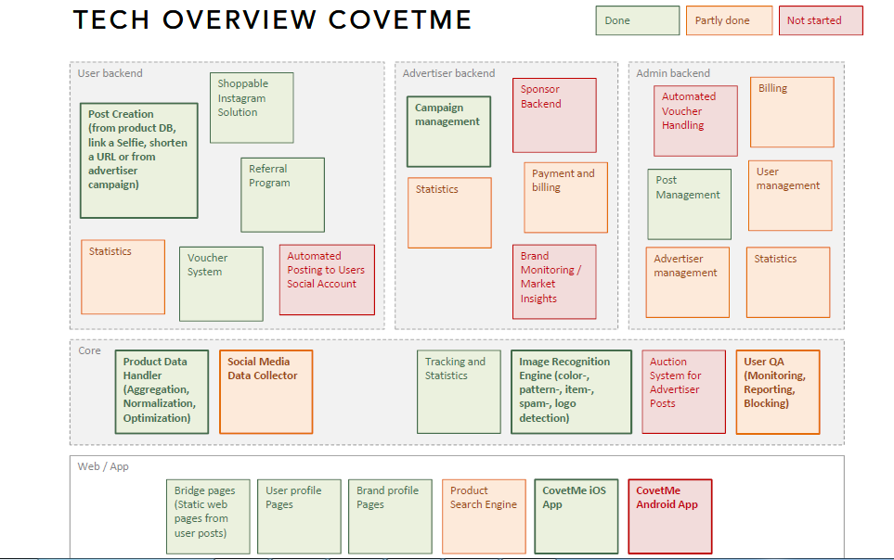

Figure 7.0 Tech Stuff

# Tools/Languages

* **Programming Languages**
  + Front and Backend: Node.js, Express as Framework
  + Image Recognition: Python
* **Database**
  + MongoDB for covetme content und data
  + Apache Solr for Product catalogue
* **Hosting on Amazons AWS EC2 SLA**
  + Autoscaling
  + Monitoring with Cloudwatch + external Monitoring via SNMP
* **Documentation and Ticketing with Jira and Confluence**

# Few More Technical Stuff

1. Fashion product catalogue of around 10m offers from various sources with clustering and normalizing algorithms on text and image basis

* Unify meta data i.e. material, type, subtype, details, color, style, pattern across languages and language variations
* Self-developed search algorithm to find best match across all languages

1. Image recognition tool suite to

* Identify color, pattern, category and subcategory of fashion items (beta) on all types of images
* Detect a logo of a brand on all types of images
* Match images on similarity
* Detect spam (adult content and alcohol detection)

# CovetMe Image Recognition

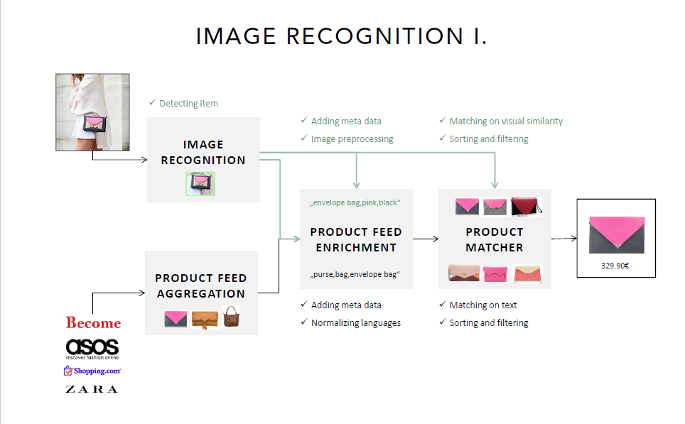

Figure 10.0 Image Recognition

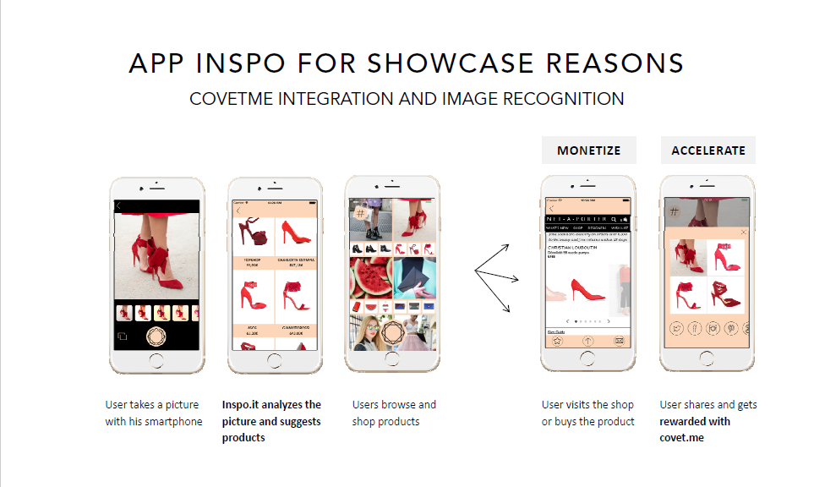

Figure 10.0 (b) App Inspo for showcase reasons

# Outlook Integration

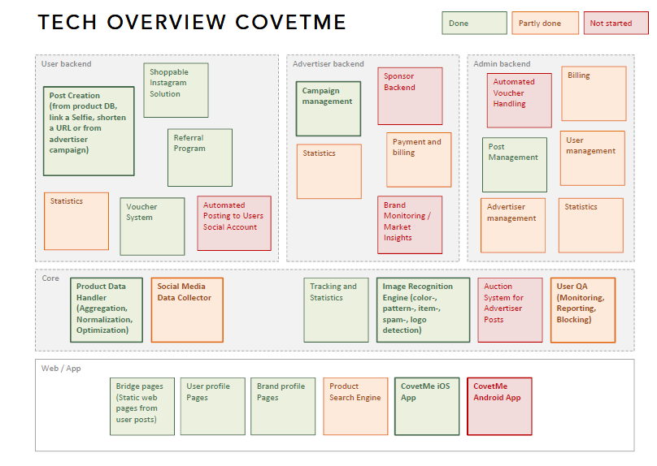

Figure 11.0 Outlook integration

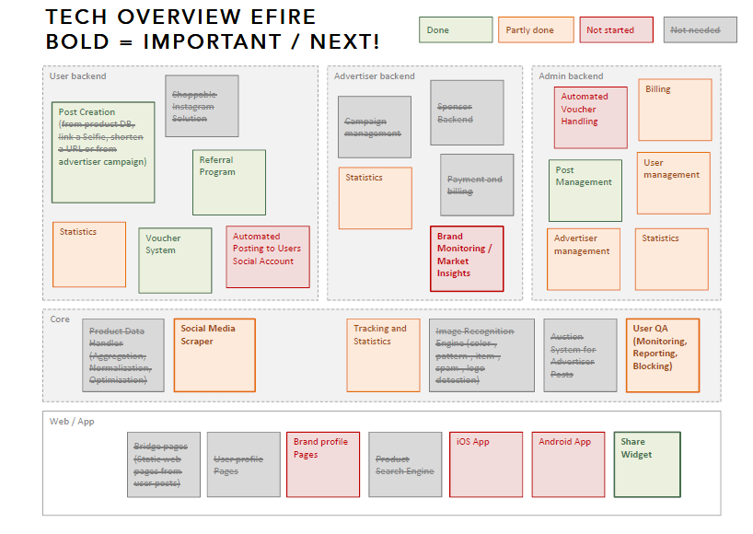

Figure 11.0 (b) Tech overview Efire bold

# Advertiser Public Social Rank & Brand Monitoring

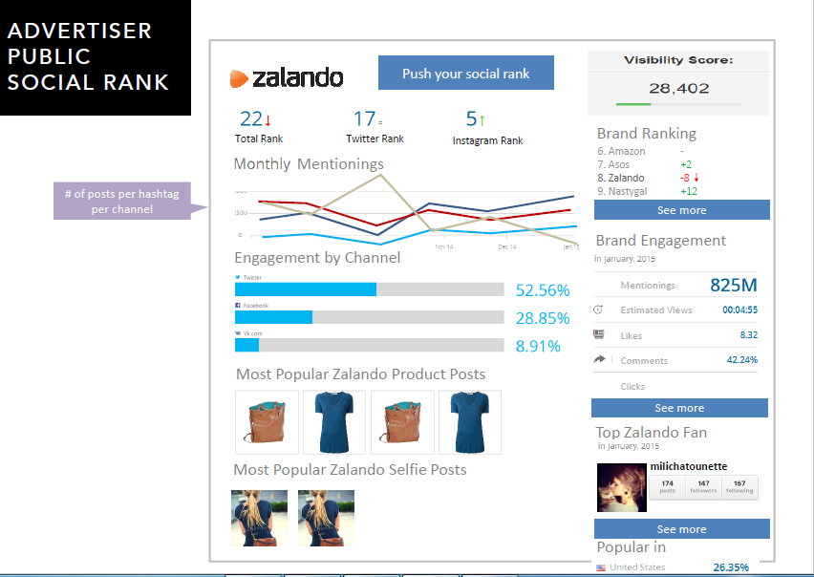

Figure 12.0 (a) Advertiser Public Social Rank

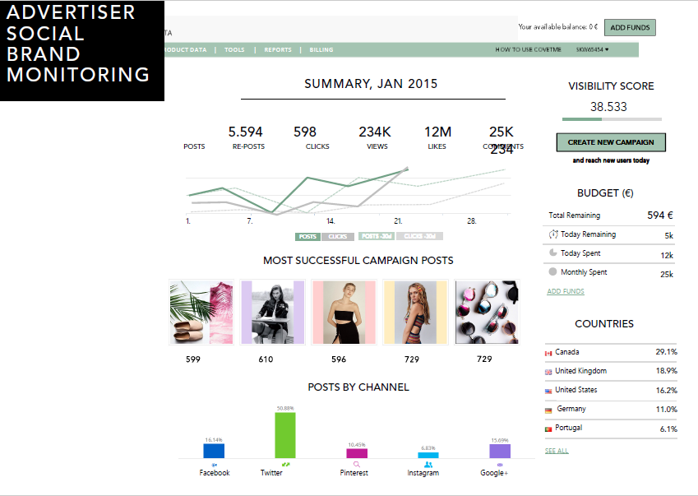

Figure 12.0 (b) Advertiser Social Brand Monitoring